L.G.N.Sewwandi ,R.P.L.Vihanga

TG/520, TG/501

Group 9

**Management Information System**

**Faculty of Technology**

**Self-Evaluation Report**

**ICT2123**

Contents

Introduction about the Role 2

Completed Task 2

Evidence for Completed Tasks 2

Student can update their profile 2

Student can view their eligibility for final exams 3

Student can view their course details 4

Student can upload their medicals 5

Problems encountered during the development of mini project 6

Solutions & how overcome the above problems 6

Tools and technologies used/ learned 6

# Introduction about the Role

For our OOD subject’s project we create a student management system using java. This is management system which can use our university. There are four main users in this system. They can do several functionalities using this system. My task is creating student’s functions. I create several classes to develop this system.

# Completed Task

* Student Update their profile.
* Student can view their eligibility for final exam.
* Student can view their course details.
* Student can upload their medicals.
* Student can view time table
* Student can view Notice

# Evidence for Completed Tasks

## Student can update their profile

Student can view their eligibility for final exams**.**

## Student can upload their medicals

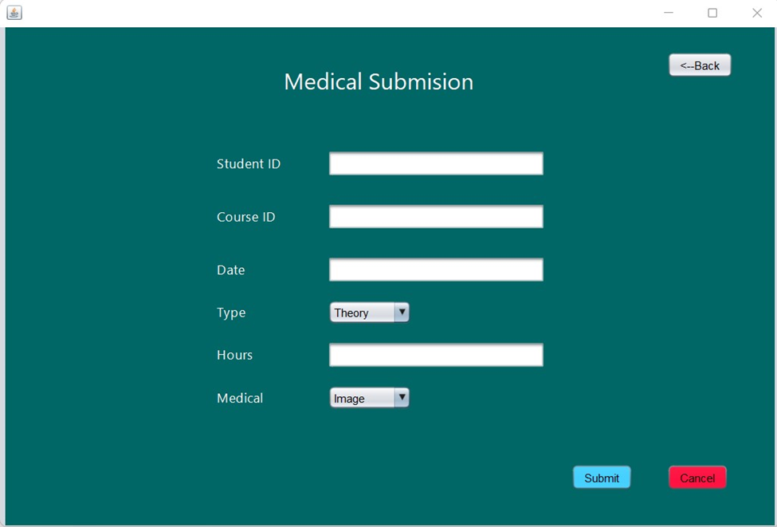

# Problems encountered during the development of mini project

* Firstly, I designed our interface then I try to make interface but while making this project I understand that some interface designs are not suitable.
* I create our database first and after that I try to calculate some calculations, but I can’t get correct calculations
* There was an error occurred when uploading the project to the git hub repository.
* We created ER and class diagram but when developing some differences were occurred
* Faced some difficulties while making interfaces

# Solutions & how overcome the above problems

* I mention above my designed interfaces are not suitable. so, to overcome this problem I change my interfaces design I make before.
* To correct my calculations, I have to add some files to our database.
* We removed the initially uploaded project from the git hub and pushed it again after taking a backup.
* Refer some YouTube videos and get an idea.

# Tools and technologies used/ learned

* Git Hub
* NetBeans IDE 12.1
* phpMyAdmin